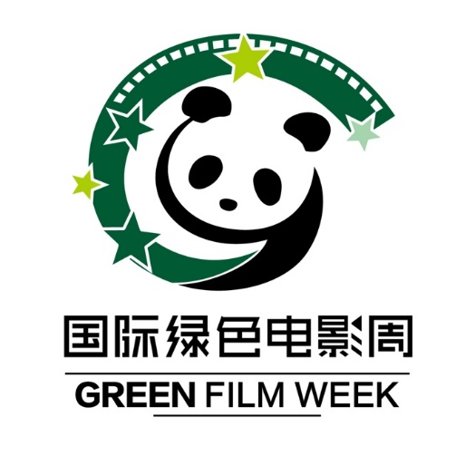

2018 China International Green Film Week Application Form

Participating Film
Film Name: | Country of Origin:
Runtime: | Completion Year:
Director(s):
First Name: Last Name:
Director(s)’s Phone Number: | E-mail:
Language: | Subtitle Language:
Participated Film Festival(s):
Synopsis:（< 100 words）
Production Company/ Independent Producer
Company Name:
Executive Producer(s): | E-mail:
Mailing Address:
Phone Number: | Fax Number:
Country: | Web Address:

Declaration:
I certify that I authorize to screen my work “ ” (please write down the film’s name) at 2018 China International Green Film Week. Any copyright materials included in my work have been legally cleared for use.
I understand that the festival is entitled to use part of my film (up to 3 minutes) for promotional purposes and I grant the festival the full permission to use the still images I supplied for all 2018 festival promotional purposes.

Outreach activities:
Besides the Film Week, we also carry out “Year-Round” on Campus screening activity, therefore

your permission is need for the following activities (Please tick any or all you are agreed with):

□ I allow my work “ ” (please write down the film’s name) to be screened for the festival’s year-round outreach activities, such as screening for the university students or the school children. It’s only for non-profit public services; the festival will not charge fees from the audiences.
Any exceptions:

I allow □ the Trailer/Clip and □ the Stills from my work shown on the particular section of the festival’s official website for promotional purpose (Non-commercial purpose).
Any exceptions:

I have read and agree to the above:
Name Signature Date

Please write down “2018 China International Green Film Week” on the envelope, and mail to the following address:
----------------------------------------------------------------------------------------------------------------------

“Organization Committee of China International Green Film Week” Beijing Office
Terrace Garden, 4th Floor, Qixing Middle Road, 798 Art Zone, No.4 Jiuxianqiao Road, Chaoyang District, Beijing, China, 100015 Tel: +86-10-5762-6455

Chinese Address:
中国国际绿色电影周组委会
北京市朝阳区酒仙桥路4号798艺术区南门内七星中街四楼花园邮编100015
电话: +86-10-5762-6455

